**Assignment 15.4**

**Build and Deploy hadoop word count program using Maven**

**Input file:**

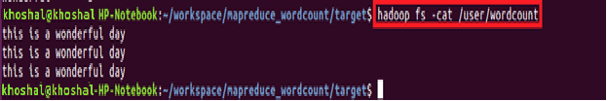

**Step1:** We will create a maven project by file->new ->maven project and maven project is created in the explorer window as highlighted.

**Driver class:**

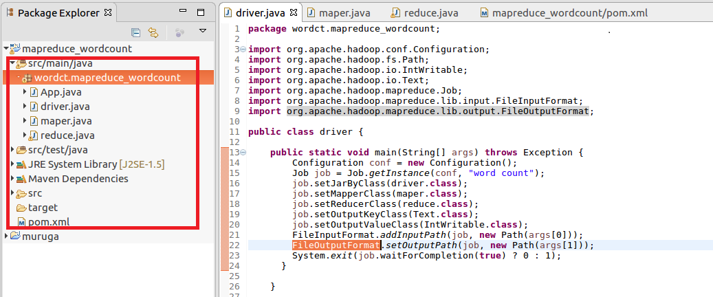

**Mapper:**

In mapper splitting the data by space and sending the word as Key and a count of 1 as value which will be added in reducer

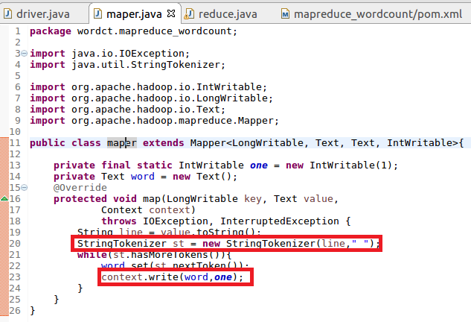

**Reducer:**

**In reduce the count of words are made**

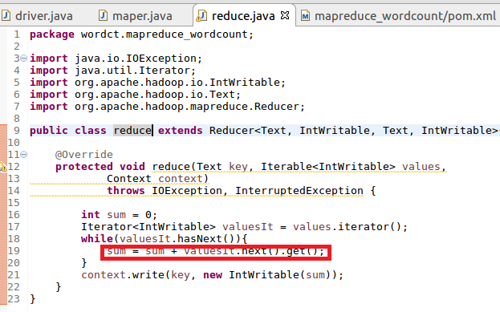

**Step2: Configuring Pom.xml file:**

**Here the necessary dependencies (command client) along with basic dependencies (java) is added.**

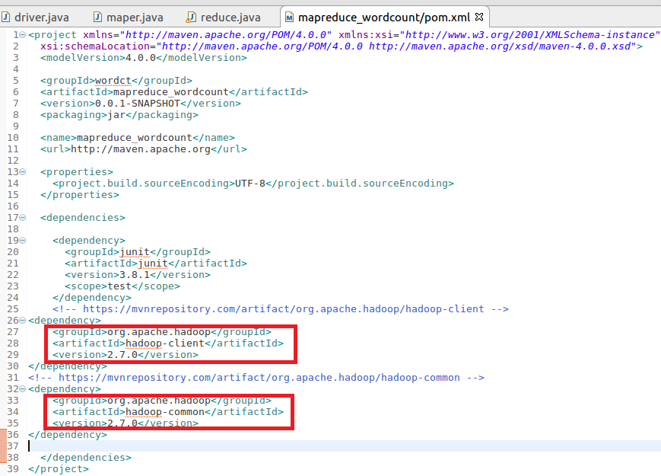

**Step3: Build maven project**

**Maven project is built by maven clean command**

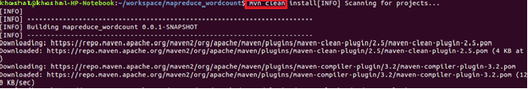

**Build successful:**

After successful completion of the building of project success message will be displayed and a jar file will be created in target folder

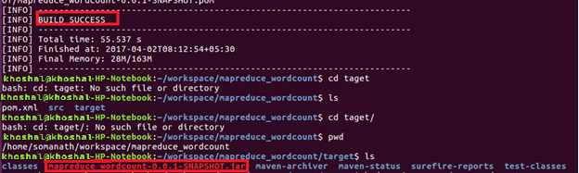

**Step4: Running Maven jar**



**Maven output:**

